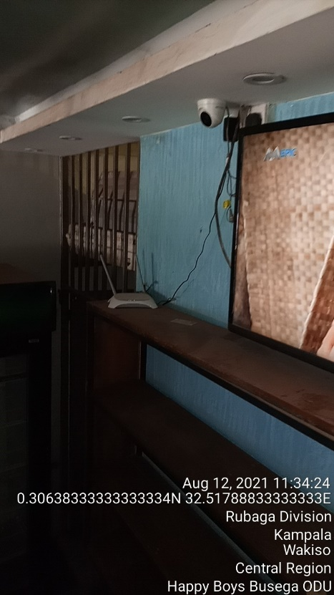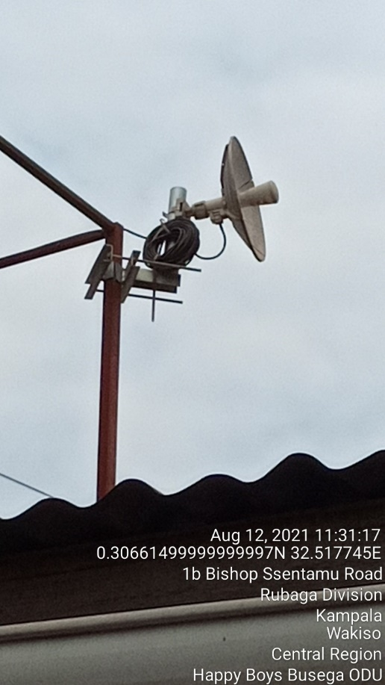
HAPPY BOYS BUSEGA IDU HAPPY BOYS BUSEGA ODU

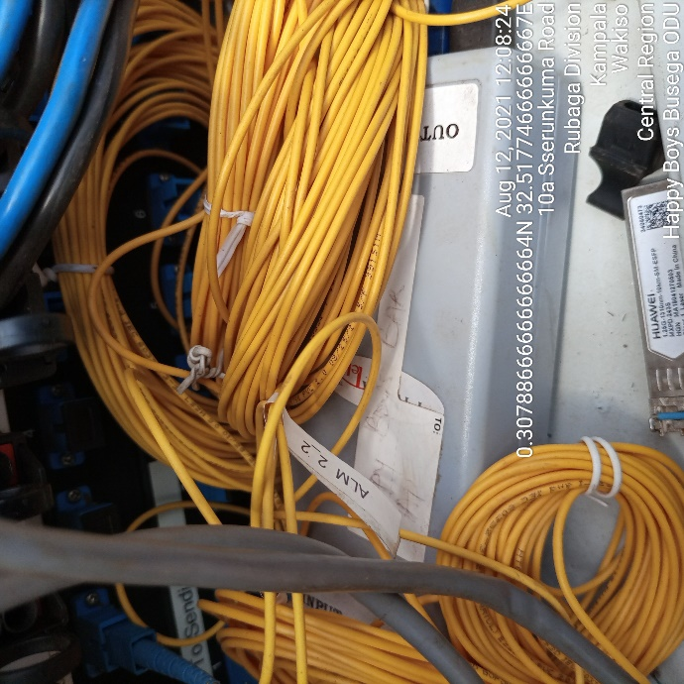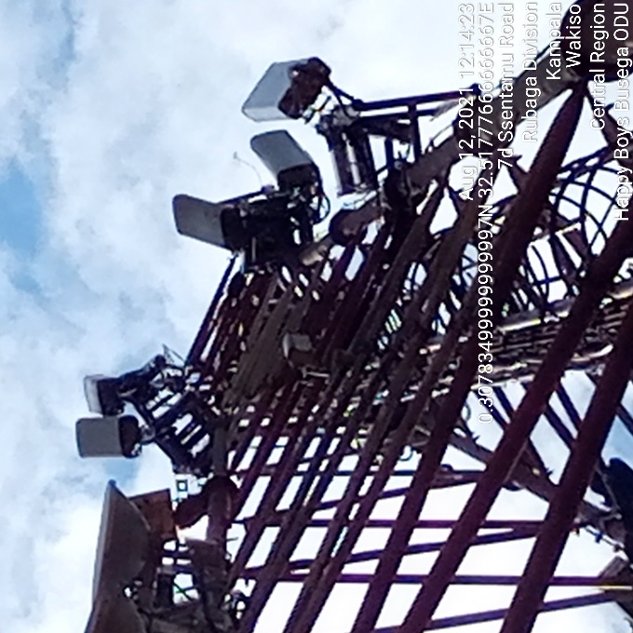
HAPPY BOYS BUSEGA IDU HAPPY BOYS BUSEGA ODU

